How to make a root file system

1. Preparation:

Download the newest busybox from the following website

<http://www.busybox.net/downloads/>

Currently, we have **busybox-1.20.1.tar.bz2**

The cross compiler is **arm-linux-gcc-4.3.2.tgz**

**mkyaffs2image-2k.tar.bz2**

1. **TODO: mkdir busybox**
2. **Copy the 【busybox-1.20.1.tar.bz2】 to the 【busybox】directory**

**cp busybox-1.20.1.tar.bz2 busybox**

1. **TODO: tar xjf busybox-1.20.1.tar.bz2**
2. **TODO: cd busybox-1.20.1**
3. **TODO: make menuconfig**
   1. Choose Busybox Settings --->

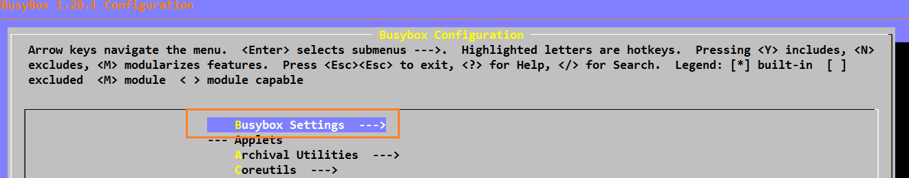

* 1. Choose General Configuration --->

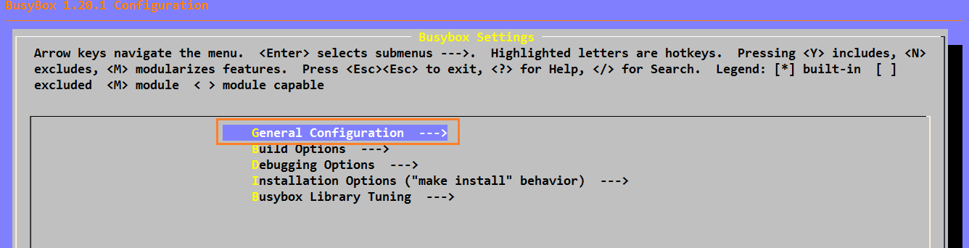

**Select [*] Don't use /usr**

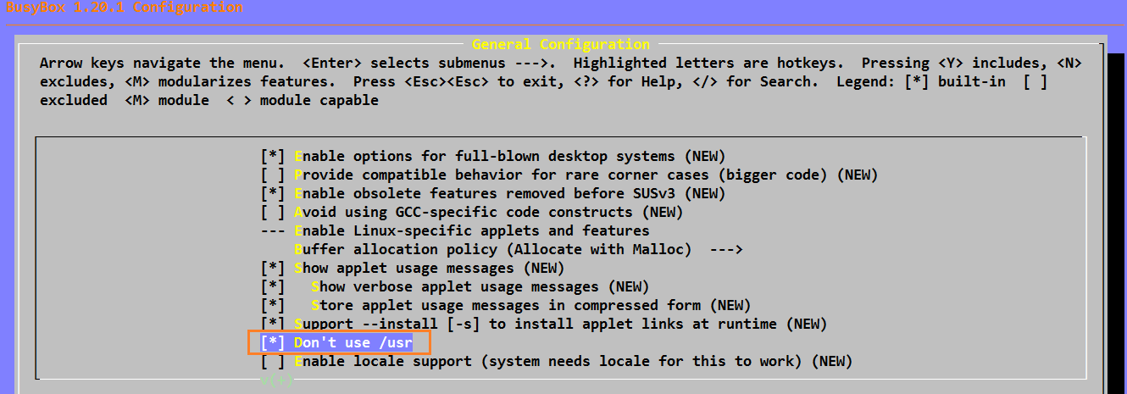

* 1. Choose Build Options --->

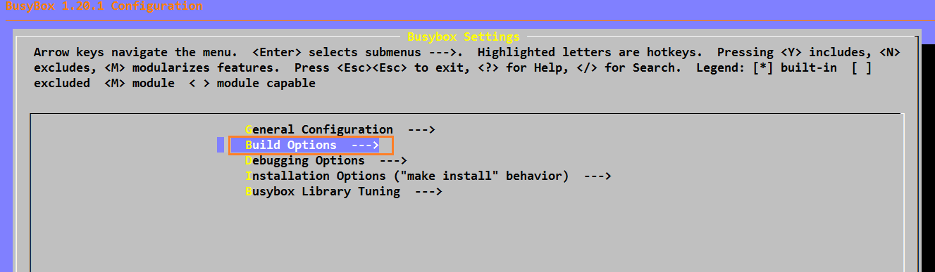

**TODO: Enter the name of the cross compiler, in this case, we have, “arm-linux-“.**

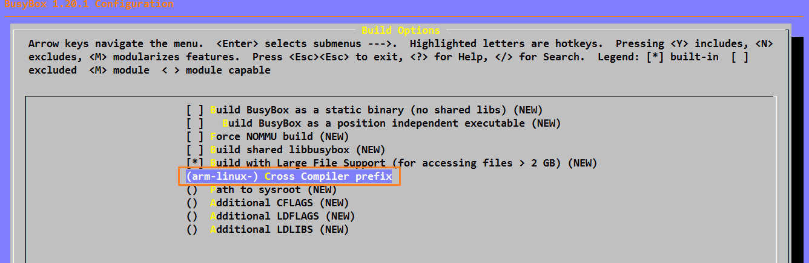

* 1. Specify the busybox installation directory

1. **Choose the Installation Options ("make install" behavior) --->**

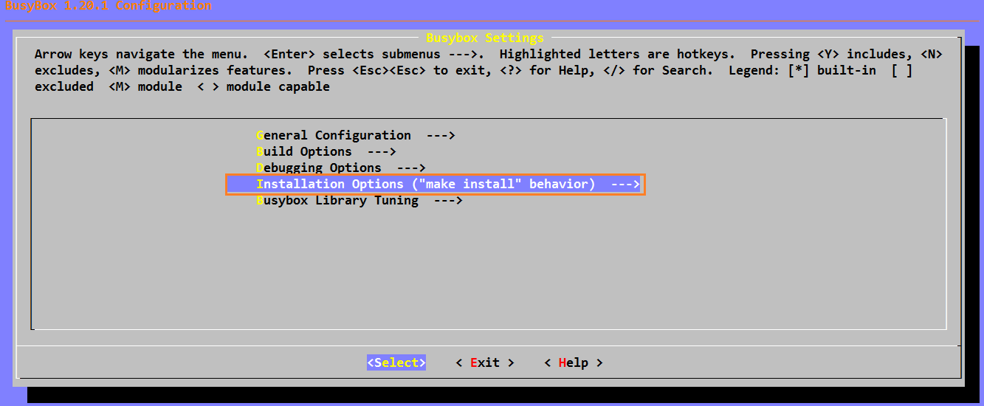

1. **Enter the specific busybox installation directory.**

**In this case, the path is**

**【/home/kyyang/yan/nfs/NovaRootfs】**

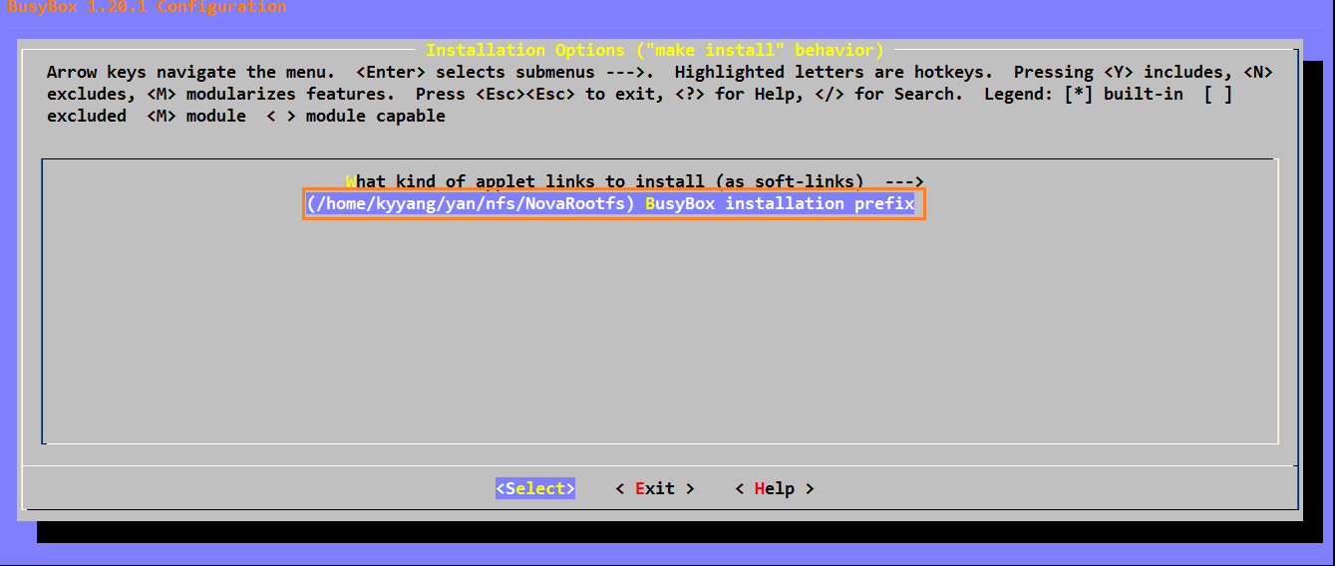

* 1. Choose the Busybox Library Tuning --->

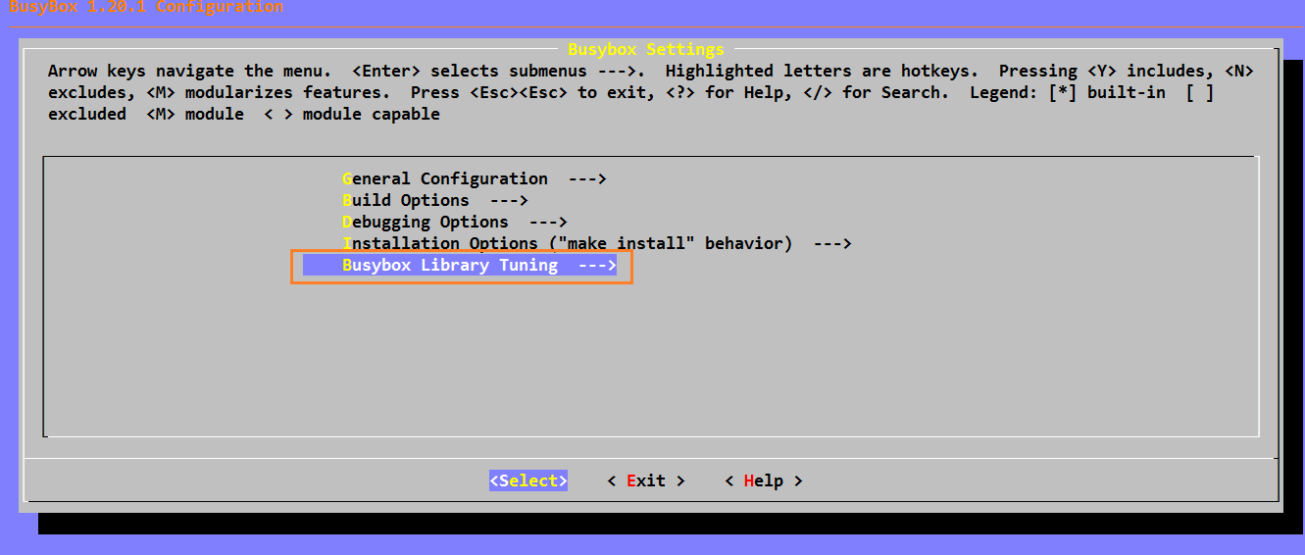**Then, Mark the following options if they are not selected:**

**TODO:**

1. **[*] Tab completion (NEW)**
2. **[*] Username completion**
3. **[*] Fancy shell prompts (NEW)**

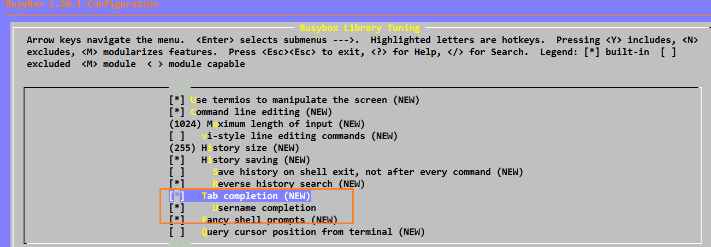

* 1. Save the new configurations and exit

**Select Exit or press <Esc> to exit the busybox configuration menu.**

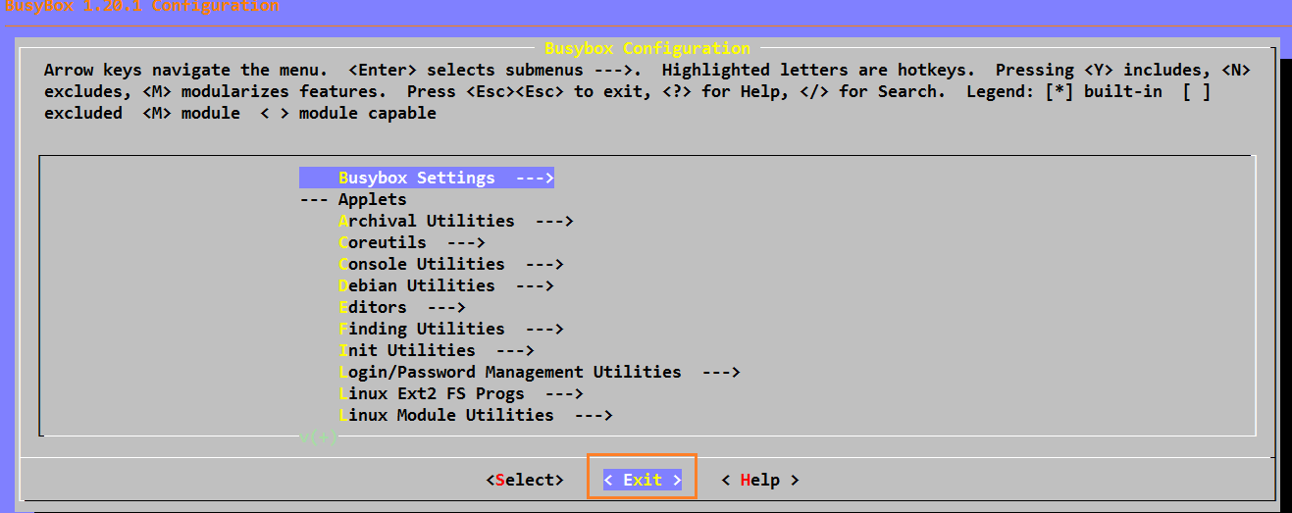

**Select < Yes > to save the new configuration.**

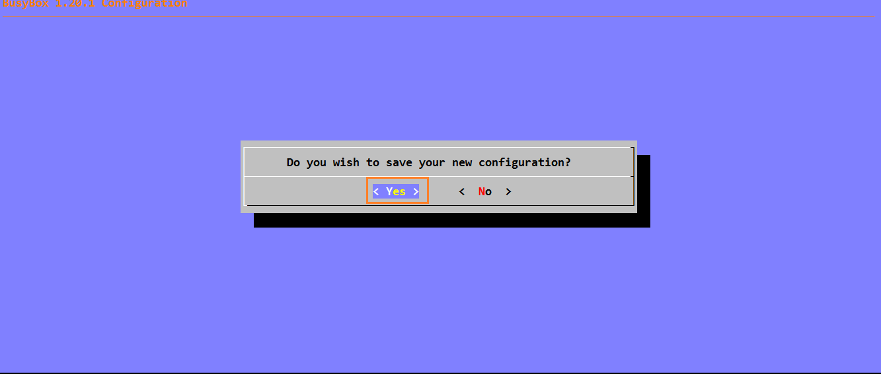

1. Now, compile the busybox

**TODO: make**

1. Install the busybox to the specific directory【See 5.4 b)】

**TODO: make install**

**(WARNING: Make sure to specify the installation directory, otherwise, the installation will crush the system).**

1. Enter the /home/kyyang/yan/nfs/NovaRootfs directory

**TODO:**

1. **cd /home/kyyang/yan/nfs/NovaRootfs**
2. **mkdir dev etc home lib mnt proc sys tmp root usr**
3. Copy the shared libraries to /home/kyyang/yan/nfs/NovaRootfs/lib directory.
4. **Assume the unzipped path for【arm-linux-gcc-4.3.2.tgz】is 【/home/kyyang/yan/cross_compiler/usr】**

**TODO:**

**To check what dynamic libraries we needed, enter the following:**

**arm-linux-readelf -a /home/kyyang/yan/busybox/busybox-1.20.1/busybox | grep "Shared"**

**D:\EMBEDDED\ARM\NorthShore\ARM lectures\Screenshots\13.bmp**

**//cd /home/kyyang/yan/nfs/NovaRootfs/lib**

**//cp -d /home/kyyang/yan/cross_compiler/usr/local/arm/4.3.2/arm-none-linux-gnueabi/libc/lib/*.so* .**

**//cp -d /home/kyyang/yan/cross_compiler/usr/local/arm/4.3.2/arm-none-linux-gnueabi/libc/usr/lib/*.so* .**

**//cp -d /home/kyyang/yan/cross_compiler/usr/local/arm/4.3.2/arm-none-linux-gnueabi/libc/armv4t/lib/*.so* .**

**//cp -d /home/kyyang/yan/cross_compiler/usr/local/arm/4.3.2/arm-none-linux-gnueabi/libc/armv4t/usr/lib/*.so* .**

**cd /home/kyyang/yan/nfs/NovaRootfs/lib**

**cp /home/kyyang/yan/cross_compiler/usr/local/arm/4.3.2/arm-none-linux-gnueabi/libc/armv4t/lib/*so* . -d**

**cd /home/kyyang/yan/nfs/NovaRootfs/usr/lib**

**cp /home/kyyang/yan/cross_compiler/usr/local/arm/4.3.2/arm-none-linux-gnueabi/libc/armv4t/usr/lib/*so* . –d**

1. Create the basic device files under the /home/kyyang/yan/nfs/NovaRootfs/dev directory

**TODO:**

1. **cd /home/kyyang/yan/nfs/NovaRootfs/dev**
2. **sudo mknod console c 5 1**
3. **sudo mknod null c 1 3**
4. **sudo mknod ttySAC0 c 204 64**
5. **sudo mknod mtdblock0 b 31 0**
6. **sudo mknod mtdblock1 b 31 1**
7. **sudo mknod mtdblock2 b 31 2**
8. **sudo mknod mtdblock3 b 31 3**
9. Create the configuration file【rcS】under /home/kyyang/yan/nfs/NovaRootfs/etc/init.d directory

**TODO:**

1. **cd /home/kyyang/yan/nfs/NovaRootfs/etc**
2. **mkdir init.d**
3. **vi rcS**
4. **In the file rcS, input the following content:**

**#! /bin/sh**

**/sbin/ifconfig lo 127.0.0.1**

**/sbin/ifconfig eth0 192.168.1.240 netmask 255.255.255.0 up**

**mount –a**

**mkdir /dev/pts**

**mount –t devpts devpts /dev/pts**

**echo /sbin/mdev > /proc/sys/kernel/hotplug**

**mdev -s**

1. **chmod +x rcS or sudo chmod +x rcS**
2. Create the configuration file【fstab】under /home/kyyang/yan/nfs/NovaRootfs/etc directory

**TODO:**

1. **cd /home/kyyang/yan/nfs/NovaRootfs/etc**
2. **vi fstab**
3. **In the file fstab, input the following content:**

**proc /proc proc defaults 0 0**

**mdev /dev ramfs defaults 0 0**

**sysfs /sys sysfs defaults 0 0**

**tmpfs /tmp tmpfs defaults 0 0**

**tmpfs /dev tmpfs defaults 0 0**

1. Create the configuration file【**inittab**】under /home/kyyang/yan/nfs/NovaRootfs/etc directory

**TODO:**

1. **cd /home/kyyang/yan/nfs/NovaRootfs/etc**
2. **vi inittab**
3. **In the file fstab, input the following content:**

**::sysinit:/etc/init.d/rcS**

**console::askfirst:-/bin/sh**

**::restart:/sbin/init**

**::ctrlaltdel:/sbin/reboot**

**::shutdown:/bin/umount -a –r**

**::shutdown:/sbin/swapoff –a**

1. Create the configuration file【**mdev.conf**】under /home/kyyang/yan/nfs/NovaRootfs/etc directory

**TODO:**

1. **cd /home/kyyang/yan/nfs/NovaRootfs/etc**
2. **touch > mdev.conf**

In order to use nfs to mount the rootfs, we need to do the following:

1. Under pc linux(such as: Ubuntu)

**TODO:**

**sudo apt-get install nfs-kernel-server**

1. Modify the /etc/exports file, adding the following content:

**TODO:**

1. **sudo vi /etc/exports**
2. **Input the content after the last line**

**/home/kyyang/yan/nfs/NovaRootfs *(rw,sync,no_root_squash)**

1. Restart the nfs server

**TODO:**

**sudo service nfs-kernel-server restart**

1. Take effect the above configurations

**TODO:**

**sudo exportfs –a**

1. Modify the【**bootargs**】parameter of the U-BOOT.

**TODO:**

1. **Reset the evaluation board, enter the U-BOOT shell prompt.**
2. **setenv bootargs "noinitrd console=ttySAC0,115200 mem=64M init=/linuxrc root=/dev/nfs rw nfsroot=192.168.1.103:/home/kyyang/yan/nfs/NovaRootfs ip=192.168.1.240:192.168.1.103:192.168.1.1:255.255.255.0:Nova:eth0:off"**

**(Where 192.168.1.103 is the IP of PC, 192.168.1.240 is the IP of the evaluation board, and the 192.168.1.1 is the gateway ip)**

1. **save**
2. Now, restart the linux kernel, the rootfs will be successfully mounted via NFS protocol.
3. If you want to make a rootfs image file (yaffs), do the following:

**TODO:**

1. **tar xjf mkyaffs2image-2k.tar.bz2 –C /**
2. **sudo chmod +x /usr/local/bin/mkyaffs2image**
3. **cd /home/kyyang/yan/nfs/**
4. **sudo mkyaffs2image NovaRootfs/ NovaRootfs.yaffs**
5. **Copy the NovaRootfs.yaffs to NFS directory**

**cp NovaRootfs.yaffs /home/kyyang/yan/nfs/nfsroot**

1. Under U-BOOT shell prompt

Enter the following commands

1. **nfs 30008000 192.168.1.23:/home/kyyang/yan/nfs/nfsroot/NovaRootfs.yaffs**

**(where 192.168.1.23 is the pc linux IP, /home/kyyang/yan/nfs/nfsroot is the NFS directory).**

1. **nand erase 0x02D60000 (where 0x02D60000 is the start address of the rootfs)**
2. **nand write.yaffs 0x30008000 0x02D60000 0x77b8c0**
3. **setenv bootargs "noinitrd root=/dev/mtdblock5 rw init=/linuxrc console=ttySAC0,115200 mem=0x4000000"**
4. **save**
5. Reset the evaluation board, the kernel will mount the rootfs from the nandflash.